Patient Name: _______________________________ DOB: _____/_____/___
Patient Address:________________________________________________
Medicare Number: ______________________________________________
Phone: _________________________ UR: ___________________________

EEG (Electroencephalograph)

EEG (Electroencephalograph)

Sleep Deprived Electroencephalogram

Clinical Indications:
_________________________________________________________________________________________________________________________________________________________________________________________________________________________________

Current medication (please provide a current list):

__________________________________________________________________________
REFERRING DOCTOR
Name: ____________________Provider Number: _________________
Signature: _________________________________________________
Date: ____/_______/______

Scan the QR code for access to EEG patient information

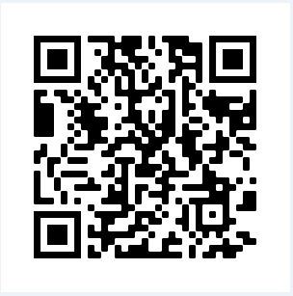

Please send your request to:
EEG Bendigo Health
COPIES TO
100 Barnard Street
Bendigo 3552
P: 54548017 F: 54548020
E: cardiology@bendigohealth.org.au

